Add the following question to #8 of the Student Satisfaction Survey:

“Check Requirements Using the Degree Audit System (DARS)”

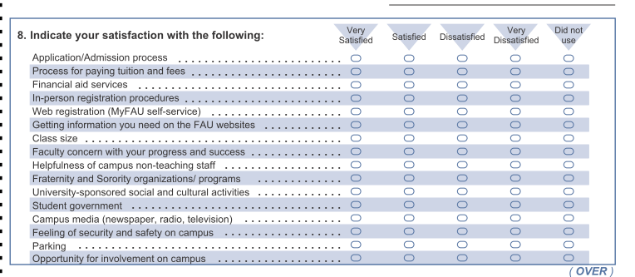

Add the following service to #9 and #10 of the Student Satisfaction Survey:

“Degree Audit System (DARS)”

